Reel Spooling Instructions

- If using braided line, it is necessary to either use a few layers on monofilament line or electrical tape on the spool, to prevent the line from slipping on the spool. We recommend tape as it’s easier and gives you the full advantage of the spool’s capacity. Some manufacturers will point this out to you in their instructions also.
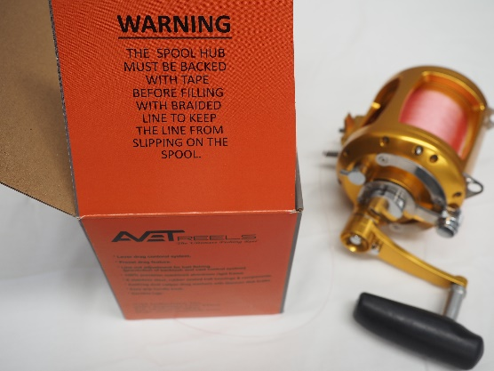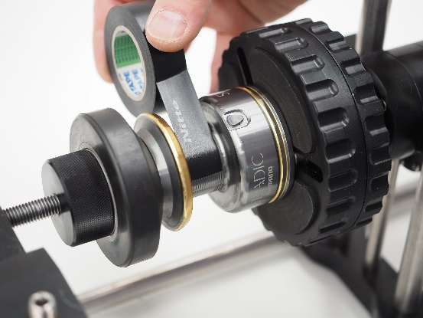
- Wrap the line around the spool 3 times before tying a knot. This will help the knot to bite down straight away and it will also help with closing the knot.
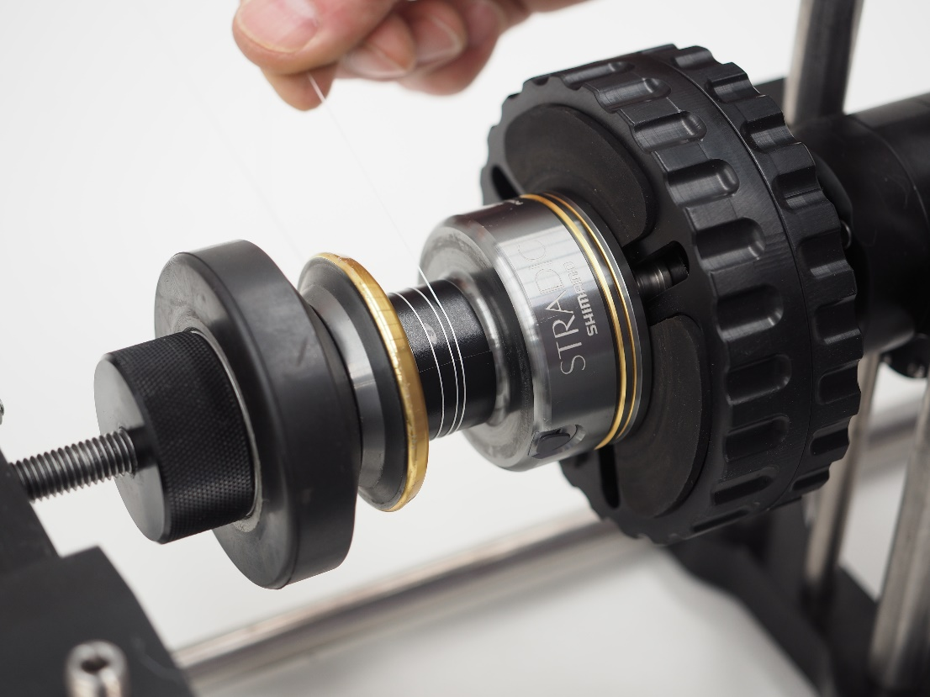

- Use a sliding knot to lock it down. We recommend a 10 turn uni knot or similar.
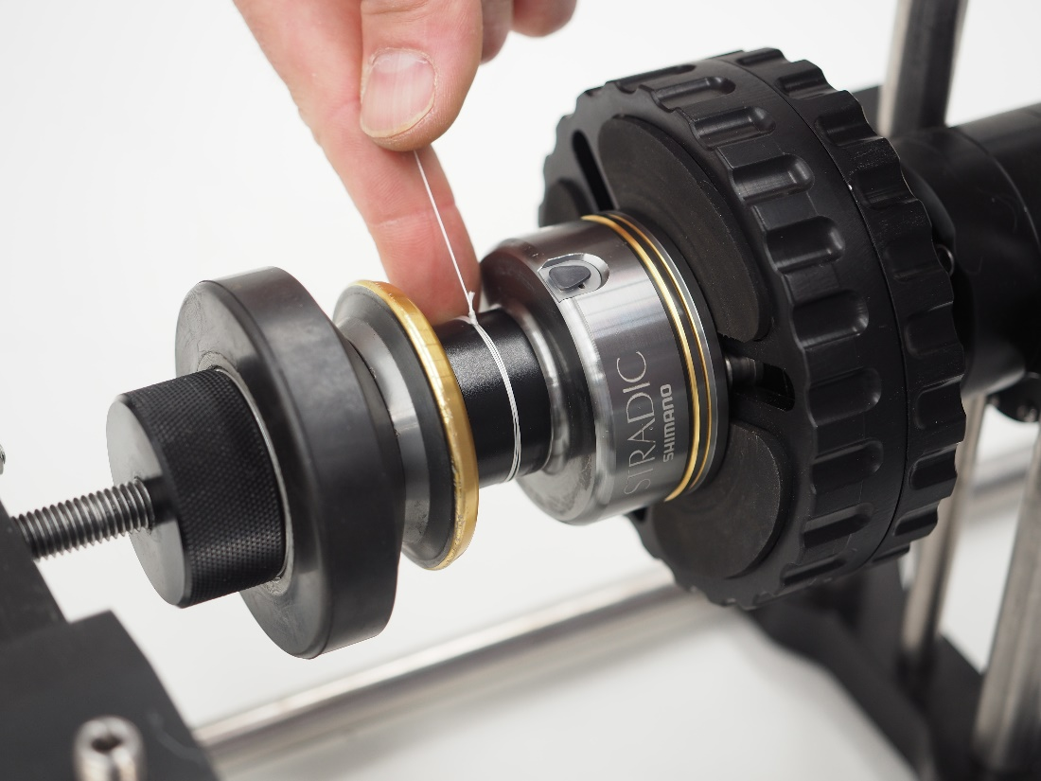

- Create a few very aggressive cross lays, using tension with a glove. This further helps the line to lock down onto the tape.
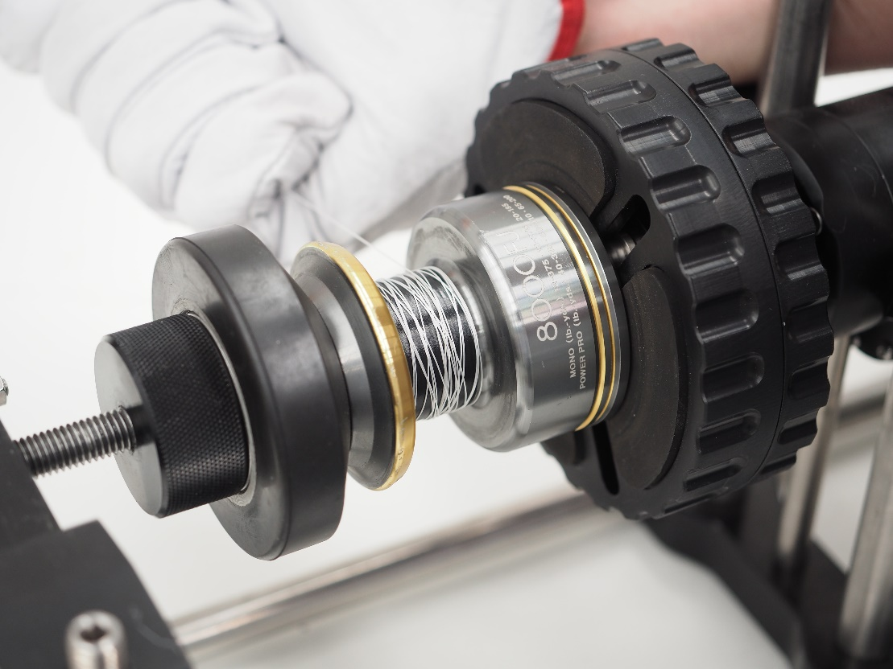

- Spool your reel under tension, preferably using a quality reel spooler. This is very important, especially with heavy drag settings as the line can dig into itself, lock up and break your line.
Don’t overfill your spool as this can lead to wind knots. We recommend to stop spooling when the line has reached the bottom of the spool lip as shown.
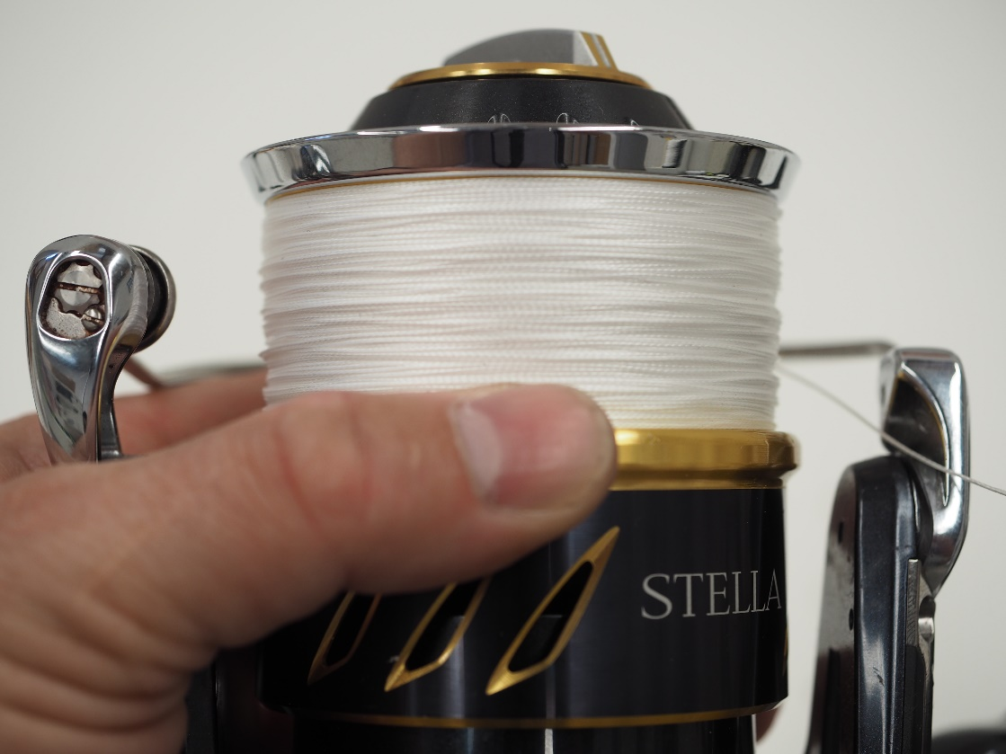
These tips can be applied for spin reels and overhead reels when braid backing is used.
It also applies whether you spool by hand or with a line winder as shown.

